Module 6
Assessment Questions:
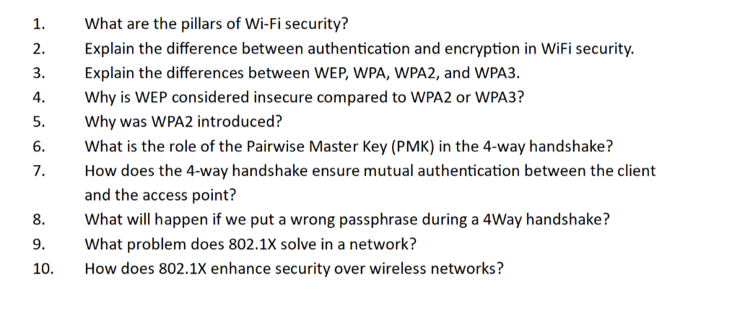
Answers :

1) What are the pillars of Wi-Fi security?
Wi-Fi security is built upon three fundamental pillars:

A. Authentication
Authentication verifies the identity of a user or device before granting network access.

Purpose
- Ensures only authorized users can connect.
- Prevents unauthorized access.

Example
- Entering a Wi-Fi password.
- Using enterprise credentials via 802.1X.

B. Encryption
Encryption protects data transmitted over the air.

Purpose
- Converts readable data into unreadable ciphertext.
- Prevents eavesdropping.

Example
- AES encryption in WPA2/WPA3.

C. Integrity
Integrity ensures data is not altered during transmission.

Purpose
- Detects tampering.
- Prevents packet modification attacks.

Example
- Message Integrity Check (MIC).

Additional Security Components
- Access Control
- Key Management
- Non-repudiation
- Availability

2) Explain the difference between authentication and encryption in Wi-Fi security
Feature | Authentication | Encryption
Purpose | Verifies identity | Protects data
When Used | Before access | During communication
Goal | Access control | Confidentiality
Example | Password, 802.1X | AES, GCMP

Simple Analogy
- Authentication is like showing your ID at a building entrance.
- Encryption is like speaking in a secret language once inside.

Process Flow
- Device requests connection.
- Authentication verifies credentials.
- Encryption secures subsequent traffic.

3) Explain the differences between WEP, WPA, WPA2, and WPA3
Standard | Year | Encryption | Security Level
WEP | 1997 | RC4 | Very Weak
WPA | 2003 | TKIP | Moderate
WPA2 | 2004 | AES-CCMP | Strong
WPA3 | 2018 | SAE + GCMP | Very Strong

WEP
- First Wi-Fi security standard.
- Uses static keys.
- Easily crackable.

WPA
- Temporary replacement for WEP.
- Introduced TKIP.
- Improved but outdated.

WPA2
- Mandatory standard for many years.
- Uses AES.
- Highly secure.

WPA3
- Latest generation.
- Uses SAE handshake.
- Resistant to offline dictionary attacks.

4) Why is WEP considered insecure compared to WPA2 or WPA3?

Major Weaknesses

Short Initialization Vector
- Only 24 bits.
- Repeats frequently.

Static Keys
- Same key used repeatedly.

Weak RC4 Implementation
- Vulnerable to cryptographic attacks.

Easy Cracking
- Can be broken within minutes.

Attack Process
- Capture packets.
- Analyze IV repetitions.
- Recover the key.

Why WPA2/WPA3 Are Better
- Dynamic session keys.
- Strong encryption.
- Secure handshakes.

5) Why was WPA2 introduced?
WPA2 was introduced to replace WPA and provide stronger security.

Reasons
- WPA used TKIP, which had limitations.
- Increasing attack sophistication.
- Need for IEEE 802.11i compliance.

Improvements
- AES-CCMP encryption.
- Better integrity protection.
- Stronger key management.
- Enterprise-grade security.

Benefits
- Higher confidentiality
- Better integrity
- Long-term security

6) What is the role of the Pairwise Master Key (PMK) in the 4-way handshake?

Definition
PMK is the master secret shared between the client and the access point.

How PMK is Generated

WPA2-Personal
- Derived from SSID and passphrase using PBKDF2.

WPA2-Enterprise
- Generated during 802.1X authentication.

Purpose
- Used to derive temporary encryption keys.
- Never transmitted over the air.

Derived Keys
- PTK (Pairwise Transient Key)
- GTK (Group Temporal Key)

Security Advantage
Even if session keys are compromised, the PMK remains protected.

7) How does the 4-way handshake ensure mutual authentication between the client and the access point?

Step 1: AP Sends ANonce
- Access Point sends a random number.

Step 2: Client Generates PTK
- Uses:
  - PMK
  - ANonce
  - SNonce
  - MAC addresses
Client sends SNonce and MIC.

Step 3: AP Verifies
- AP independently computes PTK.
- Verifies client's MIC.

Step 4: AP Sends GTK
- Encrypted using PTK.
- Includes MIC.

Step 5: Client Verifies
- Validates AP's MIC.

Result
Both sides prove they possess the same PMK.

8) What happens if we enter the wrong passphrase during a 4-way handshake?

Process
- Client derives an incorrect PMK.
- Generates incorrect PTK.
- Computes invalid MIC.

AP Verification
- AP compares received MIC.
- Verification fails.

Outcome
- Handshake terminates.
- Authentication fails.
- Client cannot connect.

User Experience
Typical messages include:
- "Incorrect password"
- "Unable to join network"

9) What problem does 802.1X solve in a network?
802.1X solves the problem of weak shared-password authentication.

Problems with Pre-Shared Keys
- One password for all users.
- Difficult revocation.
- Poor accountability.
- Security risks when employees leave.

802.1X Solution
- Individual user authentication.
- Centralized policy enforcement.
- Dynamic key generation.
- Detailed logging.

Components
- Supplicant (Client)
- Authenticator (AP/Switch)
- Authentication Server (RADIUS)

10) How does 802.1X enhance security over wireless networks?

Strong Authentication
- Unique credentials per user.

Centralized Management
- Authentication handled by RADIUS.

Dynamic Encryption Keys
- Fresh keys for every session.

Access Control
- Role-based permissions.
- VLAN assignment.

Accounting and Auditing
- Complete login records.

Security Benefits
- Prevents password sharing.
- Simplifies user revocation.
- Supports certificates.
- Ideal for enterprise networks.

Summary Table
Feature | WPA2-PSK | WPA2-Enterprise (802.1X)
Authentication | Shared Password | Individual Credentials
Scalability | Small Networks | Large Enterprises
Security | Good | Excellent
User Tracking | No | Yes

